|  |  |  |
| --- | --- | --- |
| Assignment 7 | October 7  15338673 | |
| PW Janse van Rensburg | | [Type the document subtitle] |

# Question 1

When the goal is to either graphically or algebraically describe the differential features of objects from several known collections, we will use normal discriminant analysis, whereas when the goal is to sort objects into two classes and the emphasis is to derive a rule that can be used to optimally assign new objects to the labeled classes, we will use logistic regression.

# Question 2

With QDA, we do not assume the covariance structure for all classes, this implies that we have to estimate $Σ_{k}$ for each of the *k* classes.

# Question 3

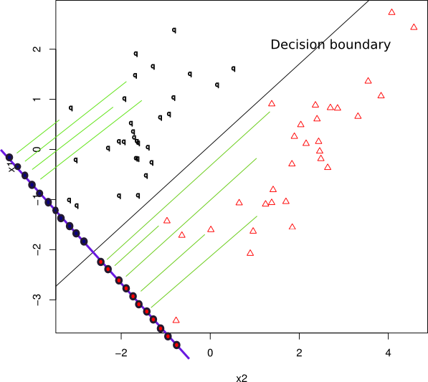

For Fisher’s linear discriminant analysis, we assume:

$$Σ_{1}=Σ_{2}=…=Σ_{k}$$

However there is no assumption of normality. The result is:

$$J\left(a\right)= \frac{a^{'S_{B }}a}{a^{'S_{w }}a}=\frac{a^{'}\left(μ_{1}-μ_{2}\right){\left(μ_{1}-μ_{2}\right)}^{'}a}{a^{'}Σa}≡Rayleigh coefficient$$

All that remains is to find a value for $a$ that maximizes the above ratio. Geometrically, we need to find $a=(μ_{1}-μ_{2})$’ $Σ^{-1}$ using the maximization lemma.

# Question 4

# Question 5

# Question 6

# Question 7

# Question 8